**ESXI VM Setup**

1. Prepare USB as bootable device for ESXI hypervisor installation. Download the hypervisor ISO and use **rufus (rufus-3.1.exe)** to create the bootable device from the ISO.
2. Insert the bootable USB device to the target machine.
3. Start the target machine and switch to BIOS to change the bootable media to USB.
4. Save the changes in BIOS and continue. Hypervisor installation should follow.
5. Proceed with appropriate inputs asked during the hypervisor installation. Please note down password for default **root** user.
6. After the installation of the hypervisor, remove the USB device and then, allow the system to restart.
7. Next, ESXI boots up and the home console appears. Press **F2** to configure the IP v4 settings. Confirm the login password to open the network setting page.
8. Select **IP v4** option and configure a static private IP address (192.168.0.x) and subnet mask (255.255.255.0). Once done, save the changes and restart the ESXI hypervisor.
9. Finally, ESXI should be booted successfully and the home / dashboard should be visible where the configured static IP address should be visible so that it can connected from a remote computer.
10. If you would like to connect the ESXI machine from your home computer then, just use an ethernet cable and connect the ESXI machine and the home computer (point to point connection).
11. Now, on the home computer you should see be able to find the unidentified public Ethernet network in Network and Sharing Center as shown below.

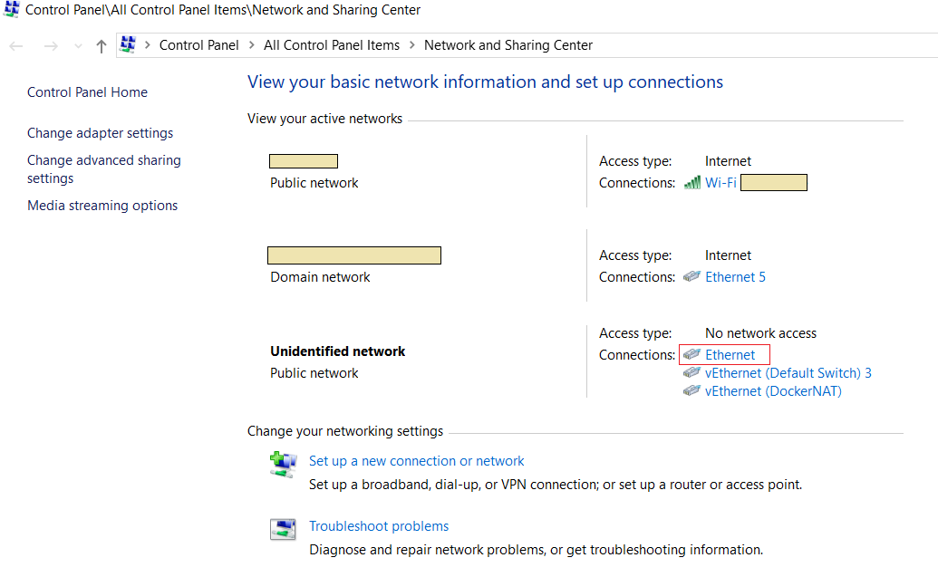

1. Click the **Ethernet** as shown above in red rectangle to set a static IP address (say, 192.168.0.y) and the subnet mask (255.255.255.0) for the ethernet network.

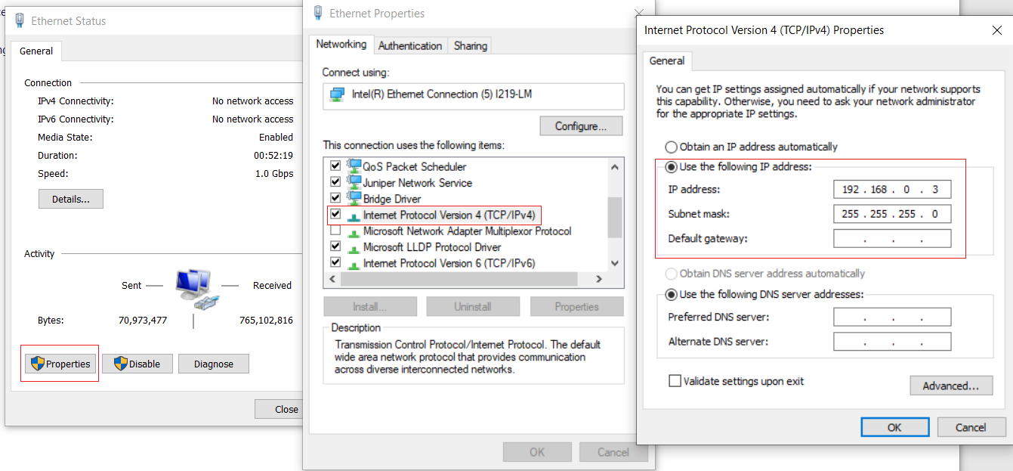

1. Next, open a browser and type the IP address of the ESXI host. This will open the ESXI login screen where user must enter the user as **root** and the password for this user. Eventually, the ESXI management console appears on the browser as shown below (2nd snapshot).

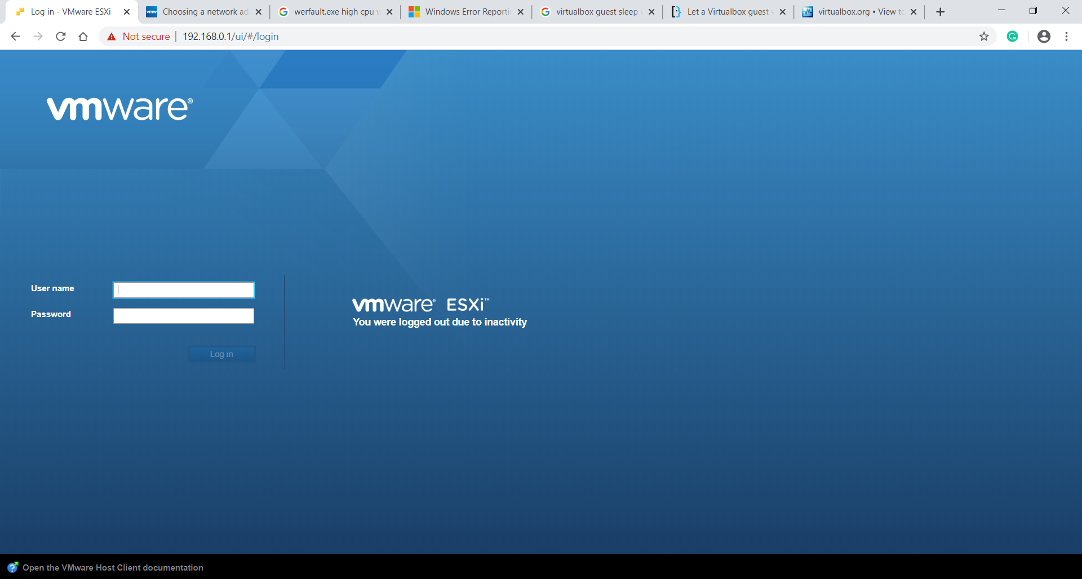

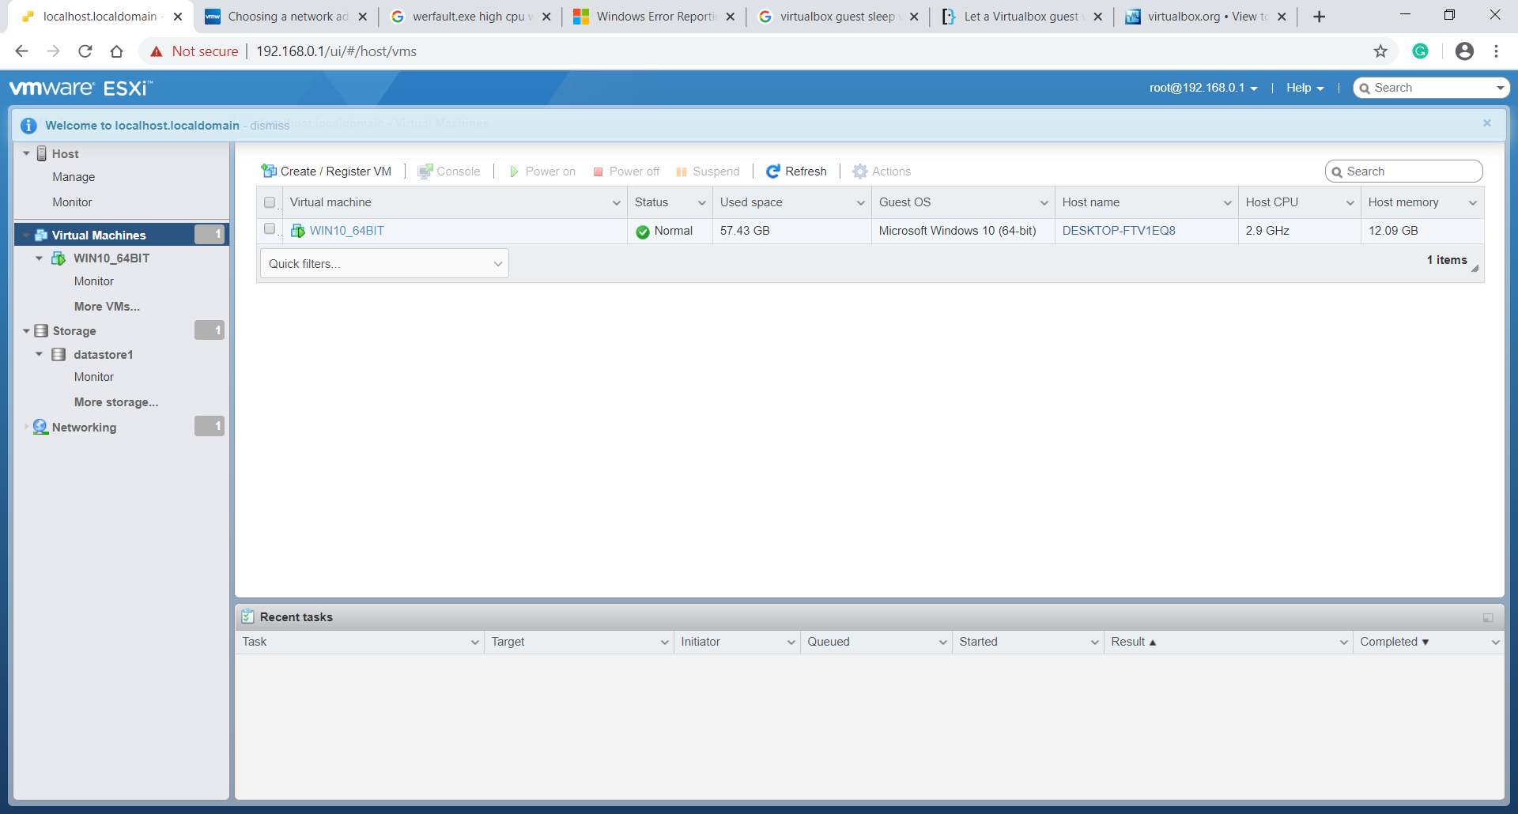

1. Now, we can create a VM on the ESXI host. However, before that, it is wise to upload the guest OS ISO and any other software ISO to the data store so that they can be accessed during the guest OS installation in the VM or the target software installation inside the VM when the guest OS is ready.
2. To access the VM from the remote home computer or vice versa, user need to configure a private static IP address (192.168.0.z) & the subnet mask (255.255.255.0) for the VM.
3. We are now ready for the ping test. Ping the remote home computer using the command: 'PING 192.168.0.y" from the VM. Similarly, it should be possible to ping the VM using command "PING 192.168.0.z" from the remote home computer.
4. Ensure that VMWare Tools is installed on the ESXI VM. This can be done from ESXI management console.
5. Please note that do not allocate all the resources of the ESXI host to the VM because there are various hypervisor services running to manage the VM and they require the resources of the host as well. General recommendation is to reserve 10% of the resources for the ESXI host.